**TWO BIT HALF SUBTRACTOR**  
**EXP.NO: 22**

**AIM:**To design and implement the two bit half subtractor using Logisim simulator.

**PROCEDURE:**  
1)      Pick and place the necessary gates.  
2)      Insert 2 inputs into the canvas.  
3)      Connect the inputs to the OR gate, AND gate and NOT gate.  
4)      Insert 2 outputs into the canvas.  
5)      Make the connections using the connecting wires.   
6)      Verify the truth table.

**TRUTH TABLE:**  
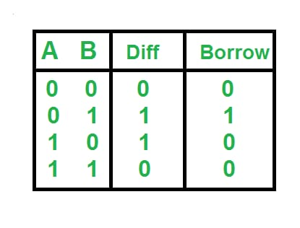  
  
  
Diff=A'B+AB'  
  
Borrow = A'B   
  
**OUTPUT**  
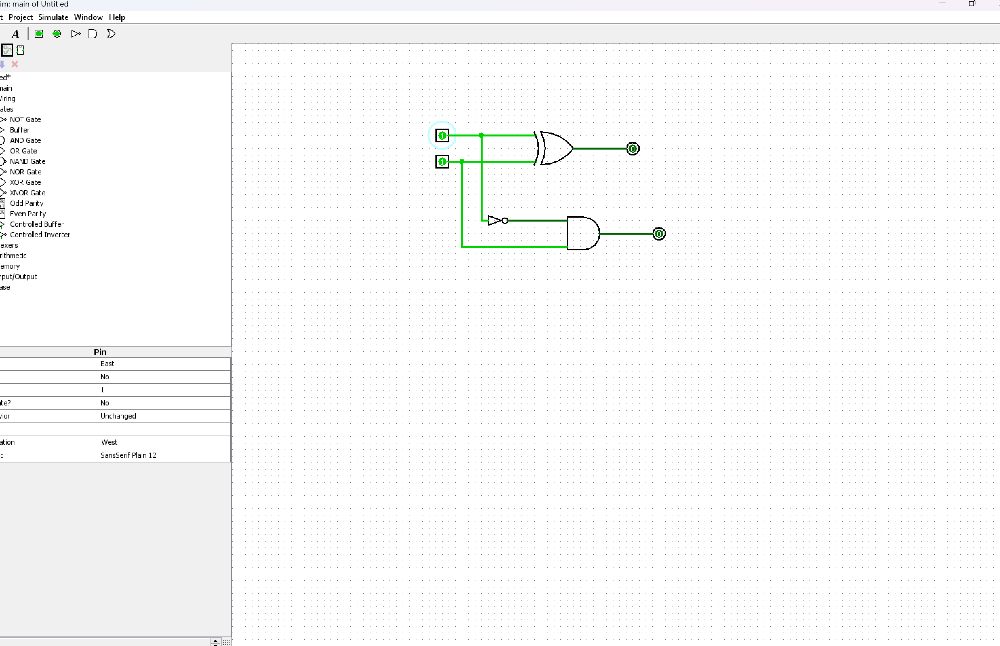  
  
  
  
  
  
  
   
  
  
  
**RESULT:**

Thus 2-bit half subtractor has been designed and implemented successfully using logisim simulator.